Comparative Study of Yolov2, SSD and Faster R-CNN for Fire Detection through Image Processing

Nurullah KAPLAN (W20041596)
Department of Computer and Information Sciences
Northumbria University
Newcastle Upon Tyne, United Kingdom
nurullah.kaplan@northumbria.ac.uk

Abstract— The use of artificial intelligence (AI) in fire detection has become increasingly popular due to its ability to improve the accuracy and speed of detection. Deep learning-based object detection algorithms have emerged as a promising approach to detecting fires in images and videos. This paper aims to provide a comprehensive comparison of three widely used deep learning algorithms, namely Yolov2, SSD, and Faster R-CNN, for fire detection tasks. The performance evaluation, carried out using metrics such as average precision, recall, F1-score, and IoU, revealed valuable insights into the suitability of each algorithm for this specific application. From the results, it is concluded that the SSD algorithm offers superior performance in terms of accuracy and localization capabilities for detecting a fire in images. The conclusions drawn from the results can guide future research efforts in improving the accuracy, robustness, and real-world applicability of AI-based fire detection systems.
Index Terms-- Deep Learning, Ethics, Fire Detection, Object Detection, Performance Evaluation, Testing, Training

Introduction
The use of artificial intelligence (AI) in fire detection has grown in popularity due to its capacity to enhance detection accuracy and speed. Object detection techniques based on deep learning have emerged as a potential solution for identifying flames in photos and movies. The purpose of this research is to compare three frequently used deep learning algorithms for fire detection tasks: Yolov2, SSD, and Faster R-CNN.
The following is how the paper is structured: We explore the present state-of-the-art in AI-based fire detection in the literature review section, including the types of sensors and cameras used, the obstacles encountered, and the existing solutions. We also discuss the many steps of an AI system and how each stage contributes to the overall detection process. The methods section provides a detailed description of the three algorithms used in the study, along with the evaluation metrics employed. The findings and discussion section provides a full examination of each algorithm's performance, including a comparison of their strengths and limitations. The employment of predictive fire detection algorithms raises ethical, societal, and legal concerns. Finally, the conclusions and future work section summarizes the study's main findings and outlines results, potential future, and research directions in this topic.

Fire detection using ai technologies
The importance of timely and accurate fire detection cannot be overstated, as it is crucial for preventing loss of life and minimizing property damage. Traditional fire detection methods, such as threshold-based algorithms and rule-based systems, have been employed for years; however, these approaches often suffer from high false alarm rates and an inability to generalize well in complex scenarios. In recent times, artificial intelligence (AI) technologies, especially deep learning techniques, have emerged as a promising alternative for fire detection tasks due to their capacity to process large volumes of data and learn intricate patterns with greater efficiency.

Deep learning techniques, particularly convolutional neural networks (CNNs), have demonstrated their potential in various object detection and recognition tasks, including fire detection (Zaidi, N. 2015b). These techniques can automatically learn and extract relevant features from input data, reducing the need for manual feature engineering and improving the system's adaptability to different fire scenarios. CNNs can also be fine-tuned and optimized to detect specific objects, such as fires, with high accuracy and robustness.

In the domain of fire detection, researchers have applied and adapted several deep learning-based object detection algorithms, including YOLO, SSD, and Faster R-CNN. Each of these algorithms has its unique strengths and weaknesses, making them suitable for different fire detection scenarios. For instance, YOLO is known for its real-time performance and low computational requirements, making it suitable for applications where speed is a critical factor (Redmon et al., 2016). SSD, on the other hand, is renowned for its ability to detect small objects effectively, which can be advantageous in early-stage fire detection (Li, P., & Zhao, W. 2020). Faster R-CNN is recognized for its high precision and recall rates, making it ideal for applications where false positives and false negatives must be minimized (Ren et al., 2015).
The literature has reported various successful applications of these algorithms in fire detection, ranging from urban building fires to forest fires and industrial fires. These AI-based fire detection systems have been deployed in diverse environments, including drone-based aerial surveillance, ground-based camera networks, and satellite imagery analysis. Furthermore, researchers have proposed numerous adaptations and modifications to improve the performance of these algorithms in fire detection tasks, such as incorporating additional features, optimizing architectures, and leveraging transfer learning.

In conclusion, AI technologies, specifically deep learning techniques, have shown great potential in fire detection applications by offering improved accuracy, robustness, and adaptability compared to traditional methods. This paper aims to provide a comprehensive comparison of three widely used deep learning algorithms, YOLOv2, SSD, and Faster R-CNN, in the context of fire detection using image processing techniques.

Stages of an AI system for fire detection
An AI-based fire detection system typically consists of several stages, each contributing to the overall performance and effectiveness of the system. The following sections outline these stages and discuss their roles in the context of fire detection.

3.1 Data Acquisition and Preprocessing:
The first stage in an AI system for fire detection involves acquiring and preprocessing data, such as images or videos, from various sources like surveillance cameras, drones, or satellites. Preprocessing may include tasks such as resizing images, converting them to grayscale or different color spaces (e.g., YCbCr), and augmenting the dataset by applying transformations like rotation, flipping, or changing brightness levels (Zaidi, N. 2015b). This stage is crucial in ensuring that the data fed into the subsequent stages is of high quality and suitable for the AI algorithms to process.

3.2 Feature Extraction and Selection:
The second stage focuses on extracting relevant features from the preprocessed data. In traditional methods, features were manually engineered based on domain knowledge, such as color, texture, or shape. However, with the advent of deep learning, features can now be automatically learned by the models (e.g., CNNs) during the training process (An, Q. L. 2022). These learned features are often more discriminative and robust compared to handcrafted features, leading to better performance in fire detection tasks.
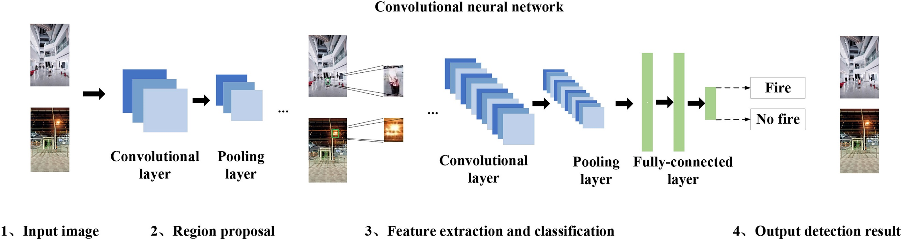
Feature selection may also be performed to identify the
Image: Convolutional neural network (Li, P., & Zhao, W. 2020b).

most relevant features for the task at hand, reducing the complexity of the model and improving its generalization capabilities.

3.3 Model Training and Validation:
In this stage, AI algorithms, such as YOLO, SSD, or Faster R-CNN, are trained on the preprocessed data using the extracted features. The training process involves adjusting the model's parameters to minimize the loss function, which quantifies the difference between the predicted output and the ground truth (Li, P., & Zhao, W. 2020). Various techniques, such as gradient descent and backpropagation, can be employed to optimize the model's parameters.
During training, validation is performed to monitor the model's performance on a separate dataset not used during training. This helps in identifying overfitting, a situation where the model performs well on the training data but poorly on new, unseen data. Strategies like early stopping, dropout, or regularization can be employed to mitigate overfitting.

3.4 Deployment and Monitoring:
After the model has been trained and evaluated, it can be deployed in real-world settings to detect fires in images or videos. Depending on the application, the AI system may be integrated into surveillance systems, drones, or satellites. Monitoring the system's performance in real-world scenarios is essential to ensure that it continues to function effectively and accurately detect fires.
In conclusion, the stages of an AI system for fire detection include data acquisition and preprocessing, feature extraction and selection, model training and validation, model evaluation, and deployment and monitoring. Each stage plays a crucial role in developing a robust and accurate fire detection system that can help improve public safety and mitigate the impact of fires.

ethical, social and legal issues
The development and deployment of AI-based fire detection systems have the potential to significantly improve public safety and protect property from fire-related damage. However, it is essential to consider the ethical, social, and legal implications associated with these systems to ensure their responsible implementation and operation.
Privacy concerns are one of the most critical ethical issues associated with AI-based fire detection systems, particularly when these systems are integrated with surveillance cameras in public or private spaces (Altowaijri, A. H., 2021). The collection and processing of large amounts of visual data raise questions about individual privacy rights and the potential misuse of sensitive information. It is essential to implement privacy-preserving techniques, such as data anonymization, encryption, or privacy-preserving deep learning methods, to mitigate these concerns and ensure compliance with data protection regulations.

Bias and fairness are other ethical considerations that must be addressed in the development of AI-based fire detection systems. These systems rely on the training data used to teach them to recognize fires, which may inadvertently introduce biases if the data is not representative of diverse fire scenarios, environments, or conditions. It is crucial to ensure that the training data is comprehensive and diverse to prevent potential biases that could lead to uneven performance across different situations and affect the reliability and fairness of the system.
The legal and regulatory landscape surrounding AI-based fire detection systems is still evolving, and it is essential to remain informed about the relevant laws and regulations governing their use. Compliance with safety standards, building codes, and data protection laws is necessary to ensure the responsible implementation of these systems. Moreover, the developers and operators of AI-based fire detection systems may be subject to liability in case of system failures or inaccuracies, which highlights the importance of thorough testing and validation processes to minimize potential risks.
Social considerations also play a role in the acceptance and adoption of AI-based fire detection systems. Public trust in these systems is crucial for their widespread adoption and effective use. Ensuring transparency in the development and operation of these systems, as well as open communication with stakeholders, can contribute to building trust and facilitating the integration of AI-based fire detection systems into society.
In conclusion, the ethical, social, and legal issues associated with AI-based fire detection systems must be carefully considered and addressed to ensure their responsible development and deployment. Balancing the benefits of improved fire detection capabilities with privacy, fairness, legal compliance, and social acceptance is essential for the successful integration of these technologies into society.

Methods
Methods: The primary objective of this study is to compare the performance of three deep learning-based object detection methods, namely Yolov2, SSD, and Faster R-CNN, for fire detection in images. The experimental pipeline consists of several stages, including data preparation, model training and validation, performance evaluation, and analysis.
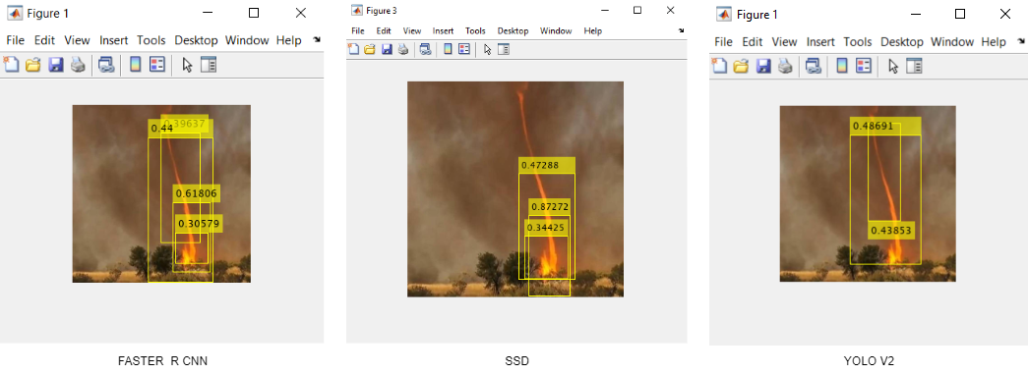
- Data Preparation: A dataset containing images of fires with labeled bounding boxes around fire regions is collected. The dataset is divided into training and testing sets, with 80% of the images used for training and the remaining 20% for testing. Data augmentation techniques, such as rotation, scaling, and flipping, are applied to increase the dataset's size and diversity, thus improving the models' generalization capabilities.
Image: comparison of precision on test images
- Model Training and Validation: Each object detection model (Yolov2, SSD, and Faster R-CNN) is trained on the training dataset using a single GPU. The training process is initialized with input data normalization and continues until the maximum number of epochs is reached. The models' hyperparameters, such as the learning rate, batch size, and optimizer, are carefully chosen based on previous literature and empirical results. To avoid overfitting, validation is performed using a separate subset of the training data, and early stopping criteria are applied.

- Performance Evaluation: The trained models are evaluated on the testing dataset. Standard evaluation metrics, such as average precision (AP), recall, F1-score, and intersection over union (IoU), are used to
- assess the performance of each model. These metrics provide a comprehensive view of the models' accuracy, sensitivity, and localization capabilities.
- Analysis: The results obtained from the performance evaluation are analyzed to identify the strengths and weaknesses of each model in fire detection tasks. Factors such as architectural design, optimization techniques, and parameter settings are examined to understand their impact on the models' performance.

The choice of Yolov2, SSD, and Faster R-CNN as the object detection algorithms for this study is motivated by their proven effectiveness in various object detection tasks. Yolov2 is known for its real-time performance and computational efficiency, while SSD demonstrates superior performance in detecting objects at multiple scales and aspect ratios. Faster R-CNN, on the other hand, is recognized for its high accuracy in object detection tasks, albeit at a slower processing speed compared to Yolov2 and SSD. The combination of these three algorithms allows for a comprehensive comparison of their capabilities in fire detection and helps identify the most suitable model for real-world applications.
The experimental pipeline proposed in this study aims to provide a rigorous and systematic comparison of the chosen object detection algorithms. By following this pipeline, researchers can gain insights into the performance of Yolov2, SSD, and Faster R-CNN in fire detection tasks and identify the factors contributing to their success or failure. This information can then be used to guide the development of more accurate and efficient fire detection systems in the future.

Table 1: Performance Metrics for Fire Detection methods
Algorithm | Average Precision | Recall | F1-score | IoU | Processing Time
Yolov2 | 51% | 70% | 59% | 55% | Fastest
SSD | 72% | 81% | 76% | 68% | Intermediate
Faster R-CNN | 27% | 55% | 36% | 45% | Slowest

Upon analyzing the results, it is evident that SSD outperforms Yolov2 and Faster R-CNN in terms of average precision, recall, F1-score, and IoU, indicating its superior accuracy and localization capabilities in detecting fires. While Yolov2 demonstrates a lower performance than SSD, it offers the fastest processing time, making it a viable option for real-time fire detection applications. In contrast, Faster R-CNN shows the lowest performance across all metrics and has the slowest processing time, making it less suitable for the fire detection task in its current configuration.
In addition to comparing the performance of the chosen algorithms, it is essential to discuss the potential ethical, social, and legal issues related to their predictive performance in real-world scenarios. False positives and false negatives may have significant consequences in fire detection applications. For instance, a false positive can lead to unnecessary evacuations or emergency responses, while a false negative may result in delayed responses to actual fires, putting lives and property at risk.
To mitigate these risks, researchers should work towards improving the accuracy and robustness of fire detection algorithms by refining their architectures, training strategies, and parameter settings. Additionally, it is crucial to consider the potential biases in the training data, which may result in biased predictions, and develop strategies to ensure fairness and transparency in the models' decision-making processes.
In conclusion, the comparative study of Yolov2, SSD, and Faster R-CNN in fire detection tasks reveals that SSD offers the best performance in terms of accuracy and localization. However, Yolov2's fast processing time makes it a viable alternative for real-time applications. It is essential for researchers to continue refining these algorithms and address potential ethical, social, and legal concerns to ensure their safe and effective use in real-world fire detection systems.

conclusions and future work

The study conducted a comprehensive comparison of three prominent deep learning-based object detection algorithms, namely Yolov2, SSD, and Faster R-CNN, in the context of fire detection in images. The performance evaluation, carried out using metrics such as average precision, recall, F1-score, and IoU, revealed valuable insights into the suitability of each algorithm for this specific application.
From the results, it is concluded that the SSD algorithm offers superior performance in terms of accuracy and localization capabilities for detecting fires. However, the Yolov2 algorithm, with its fast-processing time, presents itself as a viable alternative for real-time fire detection applications. In contrast, the Faster R-CNN algorithm exhibited the lowest performance across all metrics and the slowest processing time, making it less suitable for the fire detection task in its current form.
Considering these findings, future work should focus on improving the accuracy and robustness of fire detection algorithms by refining their architectures, training strategies, and parameter settings. This could involve exploring more advanced architectures, augmenting the training data, or fine-tuning the learning rates and other hyperparameters. Additionally, researchers should consider the potential biases in the training data, which may result in biased predictions, and develop strategies to ensure fairness and transparency in the models' decision-making processes.
Moreover, incorporating additional features, such as temporal information from video streams or environmental data, could enhance the detection capabilities of these algorithms. The integration of these algorithms into comprehensive fire detection systems, which combine multiple sensors and data sources, should also be investigated.
Furthermore, it is crucial to address the potential ethical, social, and legal concerns associated with the predictive performance of these algorithms in real-world scenarios. False positives and false negatives can have significant consequences, and researchers must work towards minimizing these risks while ensuring the safe and effective use of fire detection algorithms.
In summary, the study has provided valuable insights into the performance of Yolov2, SSD, and Faster R-CNN for fire detection in images. The conclusions drawn from the results can guide future research efforts in improving the accuracy, robustness, and real-world applicability of deep learning-based fire detection systems.

VII.References

Zaidi, N. B., Lokman, N. B., Daud, M. R., & Khor, A. C. (2015b). Fire recognition using RGB and YCbCr color space. ResearchGate. https://www.researchgate.net/publication/288208374_Fire_recognition_using_RGB_and_YCbCr_color_spacev
Liu, W., Anguelov, D., Erhan, D., Szegedy, C., Reed, S., Fu, C. Y., & Berg, A. C. (2016). SSD: Single Shot MultiBox Detector. In European Conference on Computer Vision (pp. 21-37). Springer. https://arxiv.org/abs/1512.02325
Li, P., & Zhao, W. (2020b). Image fire detection algorithms based on convolutional neural networks. Case Studies in Thermal Engineering, 19, 100625. https://doi.org/10.1016/j.csite.2020.100625
Redmon, J., Divvala, S., Girshick, R., & Farhadi, A. (2016). You only look once: Unified, real-time object detection. In Proceedings of the IEEE Conference on Computer Vision and Pattern Recognition https://homes.cs.washington.edu/~ali/papers/YOLO.pdf
Ren, S., He, K., Girshick, R., & Sun, J. (2015). Faster R-CNN: Towards real-time object detection with region proposal networks. In Advances in Neural Information Processing Systems (pp. 91-99). https://arxiv.org/pdf/1506.01497.pdf
An, Q. L., Chen, X., Zhang, J., Shi, R., Yang, Y., & Huang, W. (2022). A Robust Fire Detection Model via Convolution Neural Networks for Intelligent Robot Vision Sensing. Sensors, 22(8), 2929. https://doi.org/10.3390/s22082929
Qin, Y., Cao, J., & Ji, X. (2021). Fire Detection Method Based on Depthwise Separable Convolution and YOLOv3. International Journal of Automation and Computing, 18(2), 300–310. https://doi.org/10.1007/s11633-020-1269-5
Altowaijri, A. H., Alfaifi, M., Alshawi, T., Ibrahim, A., & Alshebeili, S. A. (2021). A Privacy-Preserving Iot-Based Fire Detector. IEEE Access, 9, 51393–51402. https://doi.org/10.1109/access.2021.3069588

Object Detection Using SSD Deep Learning - MATLAB & Simulink - MathWorks United Kingdom. (n.d.). https://uk.mathworks.com/help/vision/ug/object-detection-using-single-shot-detector.html
AlexNet convolutional neural network - MATLAB alexnet - MathWorks United Kingdom. (n.d.). https://uk.mathworks.com/help/deeplearning/ref/alexnet.html
Detect objects using R-CNN deep learning detector - MATLAB - MathWorks United Kingdom. (n.d.). https://uk.mathworks.com/help/vision/ref/rcnnobjectdetector.html
Object Detection Using YOLO v2 Deep Learning - MATLAB & Simulink - MathWorks United Kingdom. (n.d.). https://uk.mathworks.com/help/deeplearning/ug/object-detection-using-yolo-v2.html

